**Insert School Logo**

**BIOLOGY**

**UNITS 1 & 2**

**2018**

**Name**:

**Teacher**:

**Time allowed for this paper**

Reading time before commencing work: ten minutes

Working time: three hours

**Materials required/recommended for this paper**

***To be provided by the supervisor***

This Question/Answer booklet

Multiple-choice answer sheet

***To be provided by the candidate***

Standard items: pens (blue/black preferred), pencils (including coloured), sharpener, correction fluid/tape, eraser, ruler, highlighters

Special items: non-programmable calculators approved for use in this examination

**Important note to candidates**

No other items may be taken into the examination room. It is **your** responsibility to ensure that you do not have any unauthorised material. If you have any unauthorised material with you, hand it to the supervisor **before** reading any further.

**Structure of this paper**

|  |  |  |  |  |  |
| --- | --- | --- | --- | --- | --- |
| Section | Number of questions available | Number of questions to be answered | Suggested working time (minutes) | Marks available | Percentage of examination |
| Section One Multiple-choice | 30 | 30 | 40 | 30 | 30 |
| Section Two Short answer | 5 | 5 | 90 | 100 | 50 |
| Section Three Extended answer Part A | 2 | 1 | 50 | 40 | 20 |
| Part B | 2 | 1 |  |  |  |
|  |  |  |  | **Total** | 100 |

**Instructions to candidates**

1. The rules for the conduct of the Western Australian Certificate of Education ATAR course examinations are detailed in the Year 12 Information Handbook 2018. Sitting this examination implies that you agree to abide by these rules.

2. Answer the questions according to the following instruction.

Section One: Answer all questions on the separate Multiple-choice answer sheet provided. For each question, shade the box to indicate your answer. Only use a blue or black pen to shade the boxes. If you make a mistake, place a cross through that square, then shade your new answer. Do not erase or use correction fluid/tape. Marks will not be deducted for incorrect answers. No marks will be given if more than one answer is completed for any question.

Section Two: Write your answers in this Question/Answer booklet. Wherever possible, confine your answers to the line spaces provided.

Section Three: Consists of two parts each with two questions. You must answer one question from each part. Tick the box next to the question you are answering. Write your answers in this Question/Answer booklet.

3. You must be careful to confine your answers to the specific questions asked and to follow any instructions that are specific to a particular question.

4. Supplementary pages for the use of planning/continuing your answer to a question have been provided at the end of this Question/Answer booklet. If you use these pages to continue an answer, indicate at the original answer where the answer is continued, i.e. give the page number.

**Section One: Multiple-choice 30% (30 Marks)**

This section has **30** questions. Answer **all** questions on the separate Multiple-choice answer sheet provided. For each question, shade a box to indicate your answer. Use only a blue or black pen to shade the boxes. If you make a mistake, place a cross through that square, then shade your new answer. Do not erase or use correction fluid/tape. Marks will not be deducted for incorrect answers. No marks will be given if more than one answer is completed for any question.

Suggested working time: 40 minutes.

1. Biologists use classification keys to identify species. Which of the following would be used in a classification key to distinguish between different species of animal?

(a) An animal’s genome.

(b) Type of body covering.

(c) Method of reproduction.

(d) Habitat.

2. A cell placed into a hypotonic solution will

(a) lose water via osmosis.

(b) gain water via osmosis.

(c) lose solutes via diffusion.

(d) gain solutes via diffusion.

3. Facilitated diffusion involves the movement of

(a) water from a high solute concentration to a low solute concentration.

(b) solutes through a semi-permeable membrane against the concentration gradient.

(c) molecules through a protein carrier within the cell membrane, down a concentration gradient.

(d) molecules through hydrophilic channels in the cell membrane, down a concentration gradient.

4. The western swamp tortoise (*Pseudemydura umbrina*) is critically endangered. The remaining two, small populations inhabit shallow, seasonal, wet swamps on the Swan Coastal Plain. They are carnivorous reptiles, feeding mainly on insect larvae, small crustaceans and tadpoles. When the swamps dry up in late spring, the tortoises leave the water to aestivate over summer and autumn. The greatest threats to the ongoing survival of the western swamp tortoise are

(a) climate change, predators, wildfire and altered land use.

(b) mining, water pollution, climate change and salinity.

(c) pine plantations, road works, climate change and predators.

(d) drought, lack of government funding, mining and road works.

5. Captive breeding programs are crucial to the survival of many threatened species. One of the most important aspects of a successful breeding program is the

(a) release of animals into many different locations.

(b) maintenance of a diverse gene pool.

(c) creation of disease resistant organisms.

(d) establishment of nature reserves free from competition for resources.

6. An enzyme that can break down carbohydrates is called

(a) glucase.

(b) lipase.

(c) insulin.

(d) amylase.

7. Demodex mites are microscopic organisms that live on the facial skin of humans. They inhabit the pores around the eyebrows, cheeks, chin and ears, feeding on excretions from the sebaceous glands, dead skin cells and other debris. The relationship these mites have with humans could be described as

(a) beneficial.

(b) parasitism.

(c) mutualism.

(d) commensalism.

8. Energy is released from ATP as a result of

(a) phosphorylation.

(b) photosynthesis.

(c) respiration.

(d) hydrolysis.

9. Which of the following correctly displays the levels of cellular organisation from simplest to most complex?

|  |  |  |  |  |
| --- | --- | --- | --- | --- |
|  | **Cell** | **Tissue** | **Organ** | **System** |
| (a) | Glandular | Pancreatic | Pancreas | Digestive |
| (b) | Capillary | Muscular | Heart | Cardiovascular |
| (c) | Ciliated epithelium | Epithelial | Lungs | Respiratory |
| (d) | Red blood cell | Connective | Heart | Arterial |

10. Bacteria found living in and around geothermal vents are believed to metabolise inorganic compounds to synthesise energy. These bacteria should be classified as

(a) heterotrophs.

(b) chemoautotrophs.

(c) saprotrophs.

(d) chemoheterotrophs.

Question 11 refers to the diagram of the leaf cross-section below.

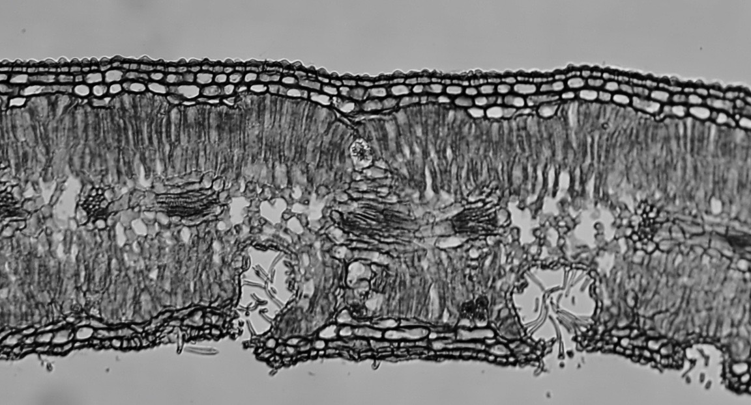

11. To which of the following plants would this leaf belong?

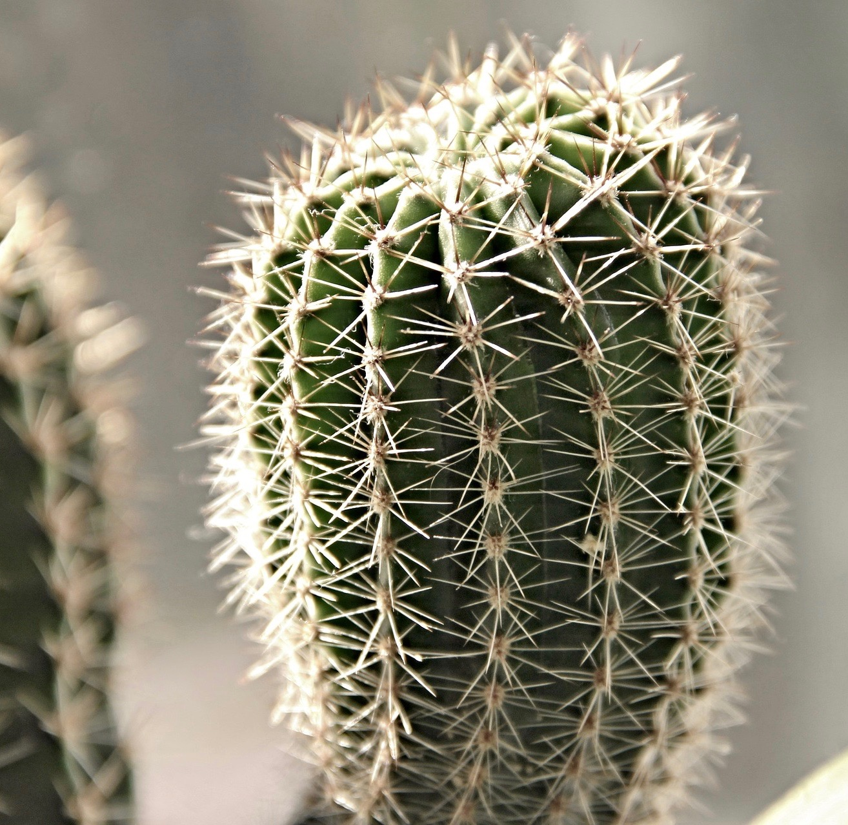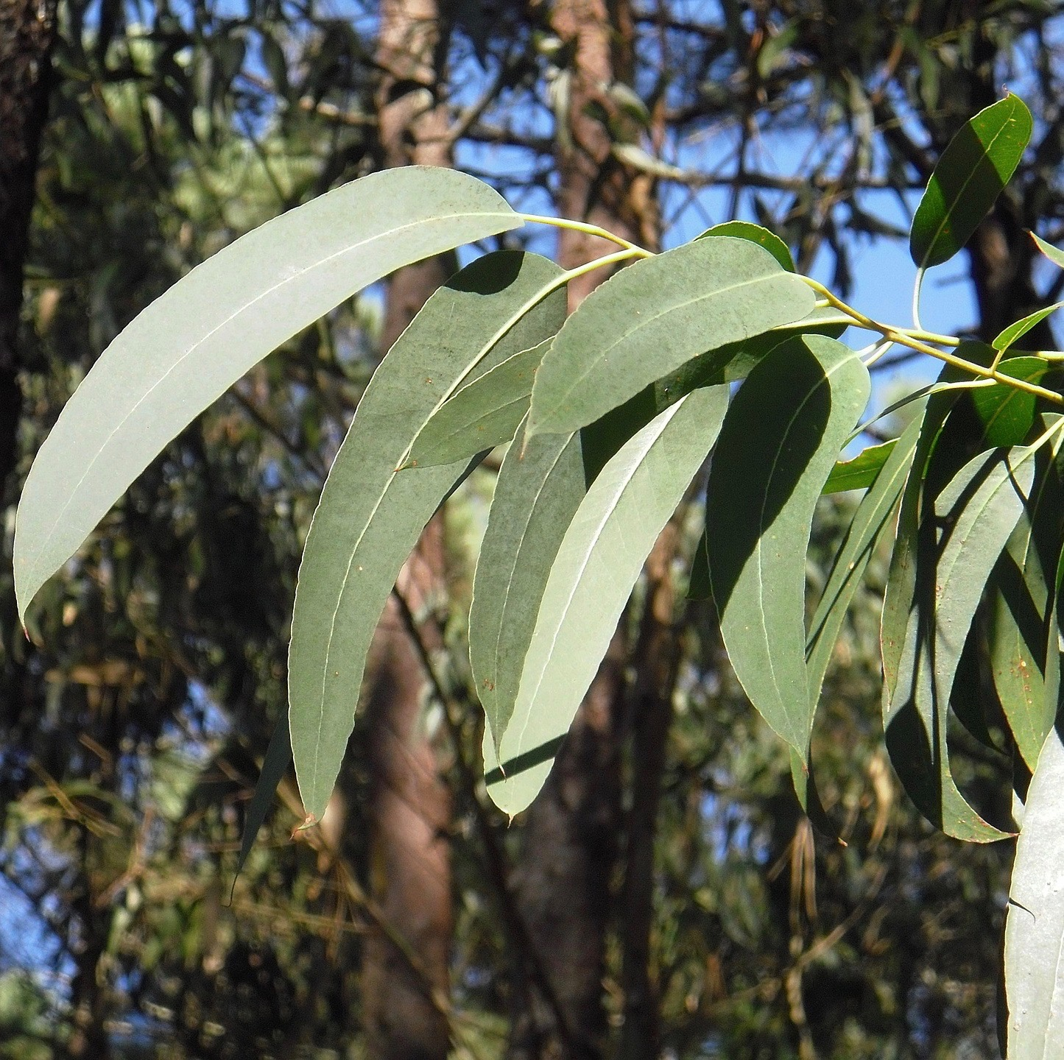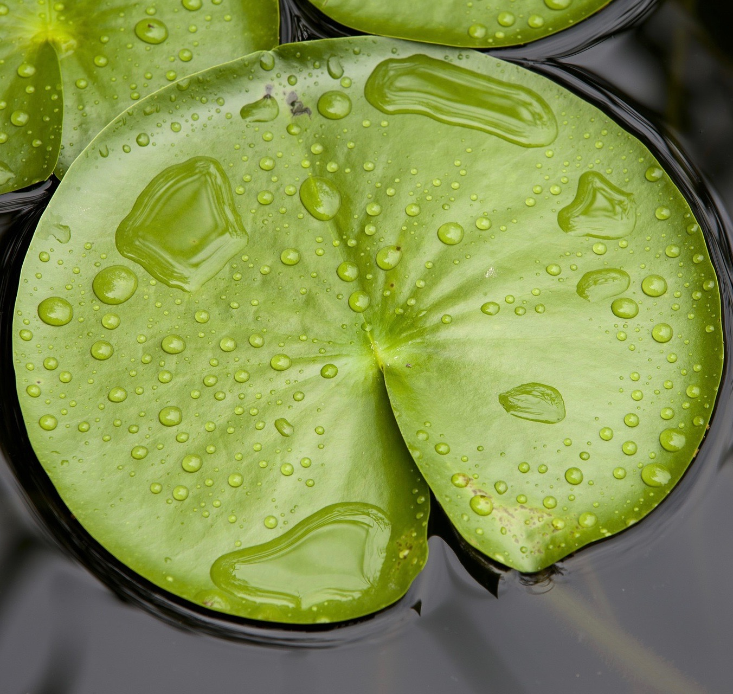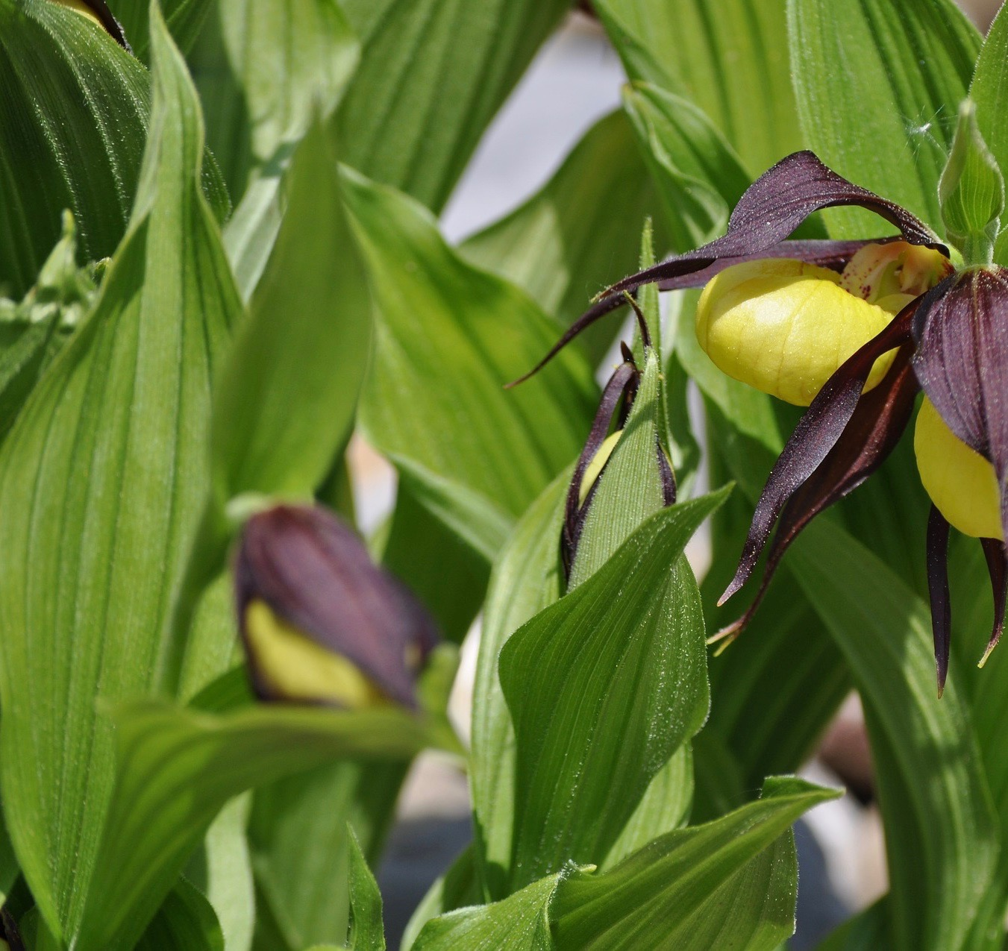

(d)

(c)

(a)

(b)

12. Grain farmers use leguminous plants in their crop rotation to boost their yield and increase profits. Which of the following statements best describes the reason for choosing legumes over other crop species?

(a) Legumes are dug into the soil when they reach maturity to increase the amount of organic matter, providing habitat for soil microorganisms.

(b) Legumes have a symbiotic relationship with soil bacteria that convert atmospheric nitrogen into ‘available’ nitrogen, which is then returned to the soil when the plant dies and decomposes.

(c) Legumes produce nodules on their roots that release oxalic acid, a natural herbicide for weeds. This reduces the application of chemical herbicides.

(d) Legumes are grown for cattle fodder to improve the nutritional value of their milk.

13. Animals that digest their food through hindgut fermentation are most likely to have a diet rich in

(a) protein.

(b) glucose.

(c) fibre.

(d) fat.

The list below outlines some of the functions of the digestive system.

F Elimination of undigested food.

G Emulsification of fats through the action of bile.

H Production of digestive enzymes.

I Physical churning of food with digestive juices.

J Reabsorption of water into the bloodstream.

K Absorption of nutrients into the blood and lymph.

L Chemical breakdown of food into smaller molecules.

14. Which of the following functions occur within the small intestine?

(a) F, J and K.

(b) G, K and L.

(c) H, I and L.

(d) G, I and K.

Question 15 relates to the image below.

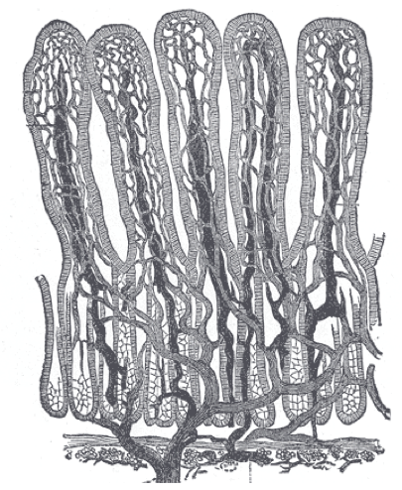

15. Which of the following combinations best describes the structure in the diagram?

|  |  |  |  |
| --- | --- | --- | --- |
|  | **Structure** | **Location** | **Function** |
| (a) | Ciliated epithelium | Bronchi | Trap and stop foreign particles entering the lungs. |
| (b) | Alveoli | Lungs | Large, vascularised gas exchange surface. |
| (c) | Villi | Small intestine | Increase surface area for absorption of nutrients. |
| (d) | Ciliated epithelium | Fallopian tubes | Sweeping ova along the tubes to meet sperm. |

16. Bony fish oxygenate their blood by continuously passing water over their gills. This type of gas exchange is known as

(a) countercurrent flow.

(b) aquatic inspiration.

(c) dissolved oxygen exchange.

(d) gill ventiliation.

17. Terrestrial mammals must possess a very efficient gas exchange surface in order to provide cells with sufficient oxygen. This exchange surface must be

(a) large, moist and thin.

(b) small, moist and thick.

(c) moist, thin and ciliated.

(d) large, thin and dry.

18. Gases are carried in the blood of animals by respiratory pigments. In chordates, oxygen is carried through the blood by a pigment called

(a) haemolymph.

(b) haemocyanin.

(c) haemoglobin.

(d) haemerythrin.

Question 19 relates to the image below.

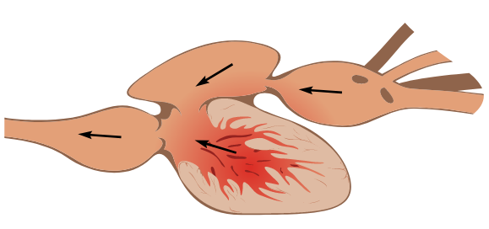

19. The heart in the image above most likely belongs to a

(a) fish, because the chambers are in sequence within a single circulatory system.

(b) frog, because it has one muscular chamber that does not separate oxygenated and deoxygenated blood.

(c) nematode, because it has four aortic chambers in sequence.

(d) cow, because it has four chambers that enable blood to be carried under pressure around its large body.

Questions 20 and 21 relate to the image below.

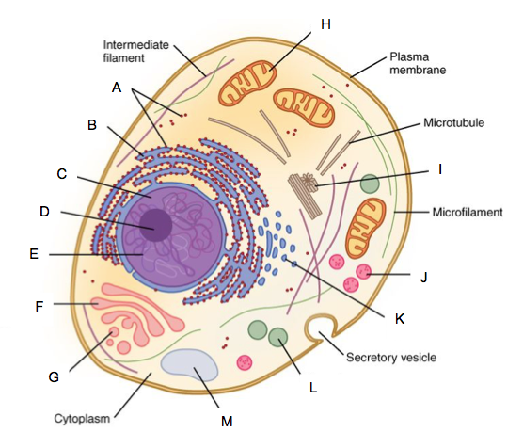

20. Which organelle in the diagram above is involved in cellular respiration?

(a) B

(b) F

(c) H

(d) J

21. Which internal structure, missing from this cell, would you find in a plant cell?

(a) Cell wall

(b) Nucleolus

(c) Lysosome

(d) Large vacuole

22. Which of the following are the waste products of anaerobic respiration in plant and animal cells, respectively?

(a) Carbon dioxide and carbonic acid.

(b) Ethylene and lactose.

(c) Ethanol and lactic acid.

(d) Sulphur dioxide and ethanol.

23. A wheat farmer reduces the capacity of his crop by 50%. The land he no longer uses lies adjacent to a state forest. After approximately 15 years, many of the plants that grow naturally in the forest have colonised the unused paddocks. This is an example of

(a) primary succession.

(b) secondary succession.

(c) wind pollination.

(d) revegetation.

24. A microbiology student needed to culture a population of *Escherichia coli* for an experiment on a new medication. She cultured the bacteria in a nutrient-rich solution over a period of seven days. Her results are displayed in the graph below.

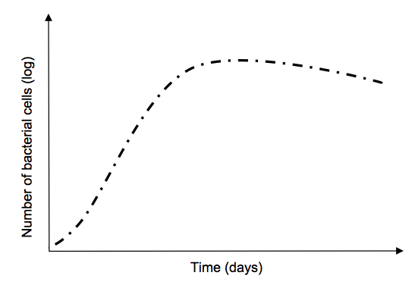

The student was disappointed when she realised the number of *E.coli* cells began to decline after four days. The most likely reason for this decline is that the

(a) solution was not exposed to enough light to enable photosynthesis.

(b) solution was not kept at the correct temperature for optimum growth.

(c) carrying capacity of the nutrient solution had been reached.

(d) bacterial culture was not prepared under sterile conditions and had been contaminated.

25. The southern cassowary (*Casuarius casuarius johnsonii*) is a large flightless bird that inhabits the rainforest of Cape York Peninsula in northern Queensland. The cassowary feeds on small animals, insects and rainforest fruit. The fruit’s seeds are distributed in their droppings throughout the rainforest. The southern cassowary is considered a keystone species because

(a) it plays a crucial role in ecosystem function.

(b) it is an omnivore.

(c) its habitat lies within a biodiversity hotspot.

(d) it is critically endangered.

26. An enzyme that has been denatured will no longer function properly. This is most likely because

(a) it can no longer recognise the substrate it usually reacts with.

(b) the 3-dimensional shape is unravelled into a polypeptide chain.

(c) its tertiary structure is broken, affecting the active site.

(d) the Golgi body is damaged and the final stages of enzyme synthesis are not completed.

27. According to conservation ecologists, the best way to conserve Australia’s biodiversity is to

(a) protect threatened species on an individual basis.

(b) save ecosystems and habitats rather than single species.

(c) increase the genetic diversity of all endemic species to protect them from future environmental impacts.

(d) protect only those species of economic and social value.

Question 28 and 29 relate to the diagram below.

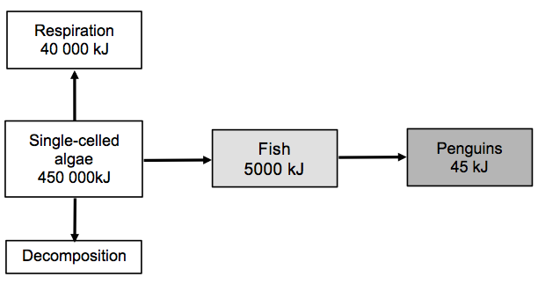

28. The diagram shows the flow of energy through a marine food chain. Less than 1% of the light energy from the sun that reaches the ocean is used by algae for photosynthesis. What happens to the remaining 99% of the light energy?

(a) It is absorbed by the consumers in the food chain.

(b) Light energy is reflected by the surface of the water, back into the atmosphere.

(c) It is absorbed by other marine autotrophs such as seagrass and seaweed.

(d) The light energy is converted to heat energy.

29. What percentage of energy is passed from the single-celled algae to the penguins in the food chain?

(a) 10%

(b) 1%

(c) 0.1%

(d) 0.01%

30. Single-celled algae are eukaryotic cells. They differ from prokaryotic cells in that they

(a) possess membrane-bound organelles.

(b) are able to carry out cellular respiration.

(c) contain DNA.

(d) reproduce asexually.

**End of Section One**

**Section Two: Short answer 50% (100 Marks)**

This section has **five (5)** questions. Answer **all** questions. Write your answers in the spaces provided in this Question/Answer booklet. Wherever possible, confine your answers to the line spaces provided. Use a blue or black pen for this section. Only graphs and diagrams may be drawn in pencil.

Additional working space pages at the end of this Question/Answer booklet are for planning or continuing an answer. If you use these pages, indicate at the original answer, the page number it is planned/continued on and write the question number being planned/continued on the additional working space page.

Suggested working time: 90 minutes.

**Question 31 (20 marks)**

A biology student was making microscope slides from a plant she found in her garden. Below is a cross-section from a part of the plant.

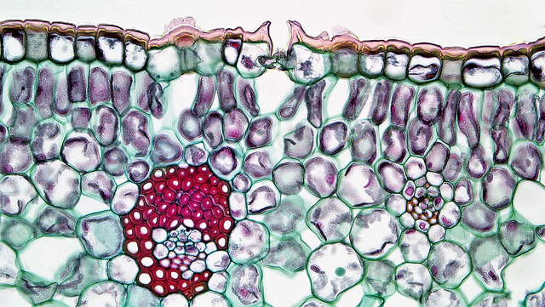

**J**

**K**

(a) Identify the cells or tissue labelled J and K in the image above and state their location in a plant. (4 marks)

J

K

(b) Identify the major role of each of these cells in a plant. (2 marks)

J

K

(c) Describe what would happen if the student placed cell **‘J’** into a concentrated salt solution. (2 marks)

(d) Identify the organelle shown in the diagram below and describe its role in the cell.

(3 marks)

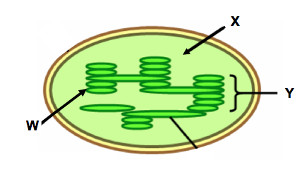

(e) Name the structures labelled W, X and Y. (3 marks)

W

X

Y

(f) Explain how each of these structures contributes to the process that occurs within this organelle. (6 marks)

W

X

Y

**Question 32 (20 marks)**

The Western Ground Parrot (*Pezoporus flaviventris*), or Kyloring, is listed as Critically Endangered under the *Commonwealth Environment Protection and Biodiversity Conservation Act 1999* (EPBC Act.) There are less than 150 birds left in the wild and their numbers continue to decline. The ground parrot’s habitat is now confined to a relatively small area of heathland on the south coast of Western Australia, as a result of devastating bushfires in late 2015. These fires, caused by lightning strikes, burnt 90% of the parrot’s habitat around Esperance, in Fitzgerald River National Park.

Historically, geographical distribution of the Western Ground Parrot ranged from Dongara (near Geraldton), around Cape Leeuwin and along the coast to east of Esperance. Human impacts have reduced this distribution to the southern part of the state, with populations limited to Cape Arid National Park, Fitzgerald River national Park, Waychinicup National Park and the Nuytsland Nature Reserve.

The Western Ground Parrot has been described as cryptic, elusive and almost impossible to see. The birds spend most of their time foraging on seeds, fruit and flowers, resting and nesting on the ground. They live in dense heathlands, preferring areas that have a diverse floral community. The parrots are believed to breed in spring, producing 2 – 4 eggs. Their nests are described as a ‘scrape’ on the ground and they only make themselves known during short periods before sunrise and after sunset. At these times, the parrots call to each other in a high-pitch whistle like a kettle. Listening for calls, either by humans or autonomous recording devices, is the current method for determining the presence, relative abundance and change in population status of the parrots.

(a) Explain why it is important that the Australian government provide the resources to support the conservation of our native flora and fauna. (3 marks)

(b) Suggest **three (3)** human-related impacts that have reduced the Western Ground Parrot’s habitat. (3 marks)

(c) In addition to fire, identify **three (3)** possible, direct threats to the Western Ground Parrot’s abundance and survival. (3 marks)

(d) Explain why the occurrence of fire would make the parrots more vulnerable to decline. (2 marks)

(e) Suggest **two (2)** problems associated with managing a captive breeding program for the Western Ground Parrot. (2 marks)

(f) Describe the limitations of estimating population numbers through non-captive techniques, such as birdcalls. (2 marks)

(g) Identify **three (3)** appropriate management strategies required to maintain the remaining populations of Western Ground Parrots on the south coast. (3 marks)

(h) Suggest why conservation officers may encounter difficulties while developing and implementing management strategies for the ground parrot. (2 marks)

**Question 33 (20 marks)**

(a) Define the following terms.

Osmolarity (1 mark)

Osmotic Potential (2 marks)

A biology student wanted to compare the sugar content of various citrus fruits – orange, mandarin, lemon, lime and grapefruit. He obtained one piece of each type of fruit and extracted the juice. The juice from each fruit was carefully decanted into five separate dialysis tubes and placed into beakers of distilled water. The tubes were left for six hours and the volume of liquid inside the tubes was then measured. The data collected is presented in the table below.

**Table 1** - *Volume of liquid in dialysis tubes after six hours.*

|  |  |  |  |  |
| --- | --- | --- | --- | --- |
| **Type of fruit (juice)** | **Volume of liquid in tubing** (mL) | | **Change in volume (mL)** | **Change in volume (%)** |
| Initial | After six hours |
| Orange | 100 | 160 |  |  |
| Mandarin | 80 | 130 |  |  |
| Lemon | 80 | 115 |  |  |
| Lime | 50 | 70 |  |  |
| Grapefruit | 130 | 195 |  |  |

(b) Calculate the percentage increase in volume for each fruit juice in the dialysis tubes. Write the answers in the ‘Change in volume (mL)’ and ‘Change in volume (%)’ columns in the table above. (2 marks)

(c) Propose a suitable hypothesis for this experiment. (2 marks)

(d) Identify the following variables in the experiment.

Independent (1 mark)

Dependent (1 mark)

(e) Construct an appropriate graph of the data on the grid below. (4 marks)



(f) Write a conclusion for the experiment based on the data presented in your graph. (3 marks)

(g) Identify **two (2)** variables that should have been controlled in this experiment.

(2 marks)

(h) Suggest **two (2)** changes that could be made to improve the fairness and/or validity of the data from this experiment. (2 marks)

**Question 34 (20 marks)**

(a) Define ‘gas exchange’. (2 marks)

(b) The structure and function of organisms within the Animal Kingdom is highly diverse. Identify **two (2)** factors that influence gas exchange in animals. (2 marks)

As the structures of living organisms increase in complexity, transporting materials into and out of cells becomes more difficult.

(c) Explain **two (2)** challenges faced by multicellular organisms in cellular transport, in comparison to unicellular organisms. (4 marks)

(d) Complete the table below regarding gas exchange in different animals. (6 marks)

|  |  |  |
| --- | --- | --- |
| **Type of animal** | **Structure/s**  **for gas exchange** | **Method of gas exchange** |
| INSECT |  |  |
| PARAMECIUM |  |  |
| AMPHIBIAN |  |  |

(e) Describe how the synthesis of organic macromolecules differs between autotrophs and heterotrophs. (4 marks)

(f) Identify the chemical elements used to synthesise the basic structure of the following polymers;

(i) Carbohydrates and lipids. (1 mark)

(ii) Proteins. (1 mark)

**Question 35 (20 marks)**

Every living cell is enclosed by a membrane.

(a) Outline **two (2)** main functions of the cell membrane. (2 marks)

(b) Explain how the structure of a cell’s membrane allows it to carry out each of these functions. (6 marks)

(c) In the space below, construct a labelled diagram of a cell membrane, using the fluid mosaic model. (6 marks)

(d) Mitochondria are enclosed within a cell membrane. Explain how the structure of this membrane influences the processes that occur within the mitochondria. (3 marks)

During the process of DNA extraction, cells are placed within a solution containing detergent.

(e) Describe the effect of detergent on the cell membrane and suggest why it is used in DNA extraction. (3 marks)

**End of Section Two**

**Section Three: Extended answer 20% (40 marks)**

This section contains **four (4)** questions.

Questions 36 and 37 are from Unit 1. Questions 38 and 39 are from Unit 2. Answer **one (1)** question from Unit 1 and **one (1)** question from Unit 2.

Use black or blue pen for this section. Only graphs and diagrams may be drawn in pencil. Responses can include: labelled diagrams with explanatory notes; lists of points with linking sentences; labelled tables and/or graphs; and/or annotated flow diagrams with introductory notes.

Additional working space pages at the end of this Question/Answer booklet are for planning or continuing an answer. If you use these pages, indicate at the original answer, the page number it is planned/continued on and write the question number being planned/continued on the additional working space page.

Suggested working time: 50 minutes

**Unit 1**

Choose **either** Question 36 **or** Question 37.

Indicate the question you will answer by ticking the box next to the question. Write you answer on pages 27 - 29. When you have answered your first question, turn to page 30 and indicate the second question you will answer on that page.

**Question 36 (20 marks)**

Dryland salinity has claimed one million hectares of land in the southwest of Western Australia. Lost agricultural production, as a result of salinity, is around $500 million per year and rising.

*“I would say without question that this is the largest environmental crisis we face, and if people don’t believe me now, they soon will.”* Dr Tom Hatton.

(a) Discuss the causes of dryland salinity and the effect it has on the environment, in regards to terrestrial and aquatic ecosystems in Western Australia.

(10 marks)

Matter cycles through the abiotic and biotic components of every ecosystem on Earth. Nutrient cycles transport chemical elements through these ecosystems, which are utilised by living organisms for growth and reproduction.

(b) Outline **five (5)** different abiotic or biotic factors that can influence carbon cycling in a terrestrial ecosystem. (10 marks)

OR

**Question 37 (20 marks)**

Carolus Linneas (1707 – 1778) was a Swedish botanist who developed the first classification system. He classified 4000 species of animals and plants using a system of binomial nomenclature that is still used in modern taxonomy.

(a) Describe the process of organising and naming living things and explain the importance of this classification system to biologists. (10 marks)

(b) Discuss the use of contemporary technologies to monitor migration routes, population status and health and breeding behaviour of marine animals. (10 marks)

**Question number**

**Unit 2**

Choose **either** Question 38 **or** Question 39.

**Question 38 (20 marks)**

(a) Describe the action of enzymes in all living things and outline the factors that can affect their function. Use a diagram to support your answer. (10 marks)

(b) Explain the process of cellular respiration in plants and animals. In your discussion, include the acquisition of molecules essential to its component chemical reactions. (10 marks)

OR

**Question 39 (20 marks)**

(a) Describe the structures and mechanisms involved in the transport of water from the soil, through a plant and back into the atmosphere. (10 marks)

(b) Distinguish between the **three (3)** main types of closed circulatory systems found in the Animal Kingdom. Use specific examples to support your answer.

(10 marks)

**End of Exam**

**Question number**

**Acknowledgements**

**Question 11**

Pixabay - CreativeCommons

<https://pixabay.com/en/nature-plants-park-flowers-tabitha-2508886/>

<https://pixabay.com/en/leaf-nature-plant-flower-garden-3185615/>

<https://pixabay.com/en/cactus-spiny-spur-prickly-plant-3186046/>

<https://pixabay.com/en/eucalyptus-leaf-leaves-tree-trees-2711285/>

**Question 15**

<https://www.flickr.com/photos/internetarchivebookimages/14778742131/>

**Question 19**

Wikimedia commons

**Question 20 and 21**

Wikimedia commons

**Question 24**

Author made

**Question 28 and 29**

Author made

**Question 31**

Wikimedia commons

**Question 32**

Comer, S., Burbidge, A.H., Algar, D., Clausen, L., Berryman, A., Pinder, J., Cowen, S., Danks, A., Pridham, J. & Butler, S. (2016). From the ashes: Creating a future for western ground parrots. [Landscope 31(4)](https://shop.dpaw.wa.gov.au/landscope/issues/product/415-landscope-vol-31-no-4-winter-2016): 11-15.

**Question 34**

Wikimedia commons